|  |  |
| --- | --- |
| KSU_logo.jpg | **King Saud University**  **College of Computer and Information Sciences**  **Department of Computer Science** |

**CSC 220: Computer Organization**

**Labwork - # 1**

**Student Name: ID:**

1. **Introduction**

In this lab-work we are going to see the advantage of simplification in the Boolean expressions so that we get a logic circuit with fewer gates.

1. **Experiments**

Q1:

SOP:

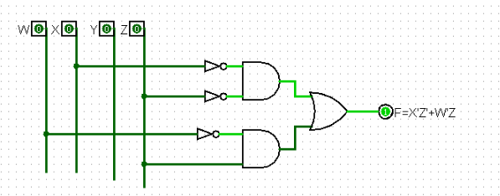

POS:

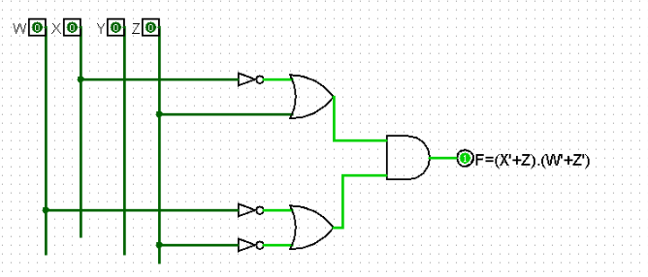

Q3:

1. **Results**

Q1:

SOP: F=W’Z’+W’Z

POS: F=(X'+Z).(W'+Z')

Q2:

B=X XOR Y XOR Z

|  |  |  |  |  |  |
| --- | --- | --- | --- | --- | --- |
| **x** | **y** | **z** | **A** | **B** | **C** |
| **0** | **0** | **0** | **0** | **0** | **1** |
| **0** | **0** | **1** | **0** | **1** | **0** |
| **0** | **1** | **0** | **0** | **1** | **1** |
| **0** | **1** | **1** | **1** | **0** | **0** |
| **1** | **0** | **0** | **0** | **1** | **1** |
| **1** | **0** | **1** | **1** | **0** | **0** |
| **1** | **1** | **0** | **1** | **0** | **1** |
| **1** | **1** | **1** | **1** | **1** | **0** |

1. **Discussion**

We see in this lab that with simplification we can get much simpler and cost efficient design for the complex circuits that we sometimes